WRITING RESOURCES CENTER
eTutor
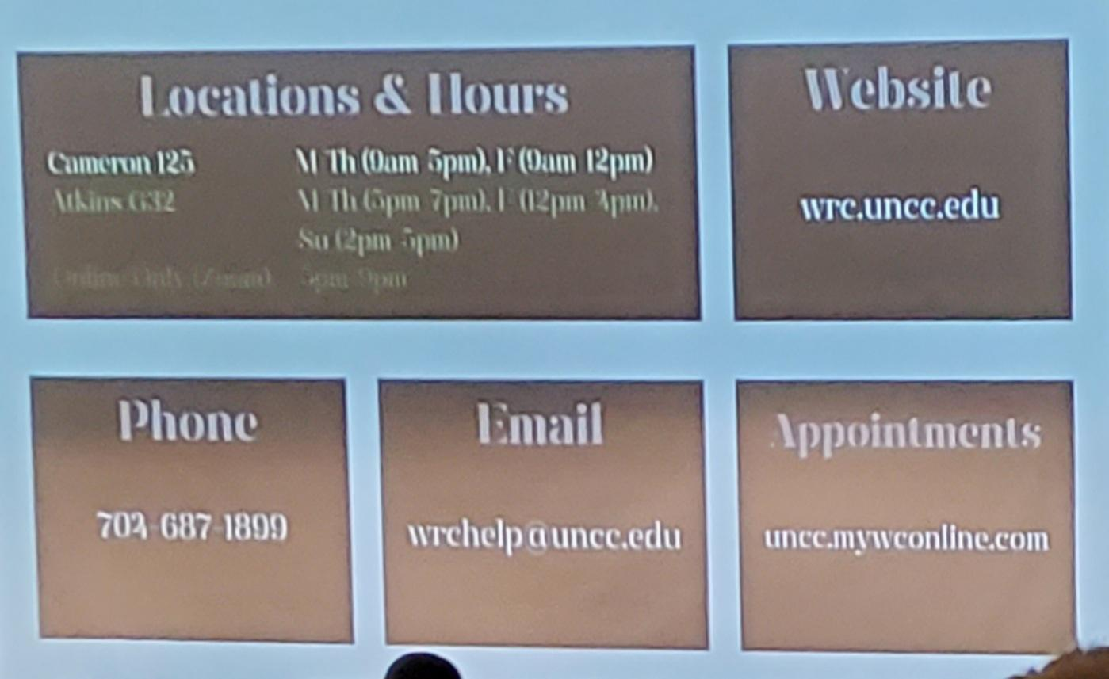

Literature Review
ITSC 2600 Literature Review Fall 2022.pdf
